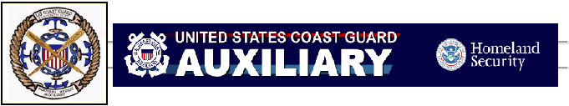
CALIFORNIA BOATER CARD INFORMATION

Beginning January 1, 2018, operators of motorized vessels will be required to possess a California Boater Card.

COAST GUARD AUXILIARY classes meet the boater safety education requirement! If you successfully completed the BOATING SKILLS & SEAMANSHIP or ABOUT BOATING SAFELY courses in 2015 through 2017, you have, or will have, satisfied the State requirement and will have six months (until 30 June 2018) to apply for the Boater Card.

Check below for required age group dates. By 2025, all persons who operate a motorized recreational vessel on California waters will be required to have one. Once issued, the card remains valid for a boat operator’s lifetime. California Harbors and Navigation Code Section 678.11(b) contains the following phase-in schedule based on operator age:
• January 1, 2018 Persons 20 years of age or younger
• January 1, 2019 Persons 25 years of age or younger
• January 1, 2020 Persons 35 years of age or younger
• January 1, 2021 Persons 40 years of age or younger
• January 1, 2022 Persons 45 years of age or younger
• January 1, 2023 Persons 50 years of age or younger
• January 1, 2024 Persons 60 years of age or younger
• January 1, 2025 All persons regardless of age

A violation of this article (Harbors and Navigation Code Section 678.15) is an infraction. Accordingly a person convicted of an infraction for a violation of this article shall be fined as follows:
• For an initial conviction, by a fine of not more than $100.
• For a second conviction, by a fine of not more than $250.
• For a third or subsequent conviction, by a fine of not more $500.

Exemptions and more information is at: http://dbw.parks.ca.gov/pages/28702/files/CBC%20FAQ%20Separate%20Pages%202.9.2017.pdf

Sign up for a class with a Flotilla near you!
Email: fso-pe@a1130807.uscgaux.info

Coast Guard Vessel Safety Checks
28 May 2017
Lake Mendocino
by request of
Army Corp of Engineers

Please have the following required items ready for the Vessel Examiner to make your vessel safety check go smoothly and quickly:
- Registration
- PFDs/Life Jackets
- If over 16 feet: A Type IV PFD/
CG Approved flotation cushion or ring buoy
- Fire Extinguisher
- Inland Distress Signal Flag (we have a few if you don't)
- Battery is hooked up to test horn, lights & blower
- Install stern light pole / all around white light

Comprehensive list:
Display of numbers
Vessel registration
Life Jackets (open so we can read the CG approved number)
Type IV USCG Approved PFD (throwable with handles) [vessels over 16']
Fire Extinguisher/s
Ventilator
Backfire Flame Control (for inboard motors)
Sound producing device (whistle, horn, bell)
Navigation Lights, front and back
Battery strapped down or enclosed
Overall vessel condition

If you do not pass, and you are pulled over, you will be asked to leave

