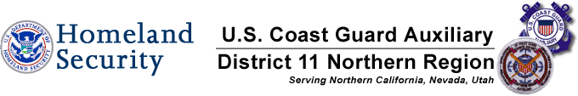

2011 Vessel Safety Check Summary

This is a brief recap of all vessels examined by Mike Lauro DSO-VE vs. National recap .The National Stats are from 2003.

965 Lauro Examinations 100,650 National Examinations *
608 Passed-63% 75,386 Passed-74.9%
357 Failed- 37% 25,264 Failed- 25.1%

Breakdown of Vessels Examined by Mike Lauro*

Total VSC’s Performed PCT of Total VSC’s Performed
163 PWC’s 17%
126 Vessels 40 to 65 ft in length 13%
215 Vessels 26 to 39 ft in length 22%
410 Vessels 16 to 25 ft in length 42%
51 Vessels less than 16 ft ex PWC’s 5%
965 Total Vessels

The following is a recap of the 357 failures, reasons, numbers, and percentages vs. National percentages. The percentages of failures will NOT add up to 100% as many vessels had multiple reasons for failing.
Reason: # Failures % of Failures National Stats**
1-Display of numbers 49 7% 5%
2-Registration 32 12% 5%
3-Personal Flotation Devices 81 15% 3%
4-Visual Distress Signals 48 13% 12%
5-Fire Extinguishers- 26 9% 4%
6-Ventilation- 9 3% 1%
7-Backfire Flame Control 8 2% 2%
8- Sound Producing Devices 166 31% 5%
9-Navigation Lights 53 4% 8%
10-Pollution Placard 26 4% 2%
11-MARPOL Placard 12 2% 3%
12-Marine Sanitation Device 1 0% 3%
13-Navigation Rules 8 1% 3%
14-State Requirements 13 3% 10%
15 Overall Vessel Condition 31 4% 4%

*These vessels were examined at Lake Camanche and throughout the Delta. Unfortunately very few vessels were examined in COASTAL WATERS.

**National stats from 2003 are not broken down by pass or failure numbers, length, or area.

Michael J. Lauro DSO-VE

Rev. 12/11 MJL/sl

