What are the benefits of a VSC?

The Vessel Safety Check
(VSC) can identify
SAFETY and money saving
Opportunities:
1-By meeting federal, state
and local safety equipment
requirements you will prevent
equipment related citations.
2-You may receive a boating
insurance discount from
your insurance provider.
3-By increasing awareness
of safety practices to avoid
accidents and costly breakdowns.
4-The VSC can reduce
accidents by educating the
boater about the value and
use of safety equipment and
safe practices on the water.

For more information
Contact:
Michael J. Lauro
Vessel Examiner
U.S. Coast Guard
Auxiliary

Phone: (209) 334-2006
Email: sumfun@juno.com
or
www.safetyseal.net

“Boat Smart from the start with a
Vessel Safety Check!”

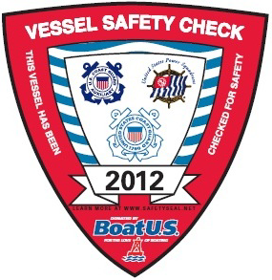

From the:
U.S. Coast Guard
Auxiliary
What is a Vessel Safety Check (VSC)?

It is an opportunity to have your vessel’s safety equipment examined by a qualified vessel examiner of the U.S. Coast Guard Auxiliary. There are NO fines, penalties, or reports to any agency.
If your vessel is properly
equipped, you will be awarded the current VSC decal to display on your vessel. Display of the decal does NOT guarantee that you will not be boarded.
But, provided you do not remove any equipment, you’ll have peace of mind knowing you have the required equipment in an emergency and know where it’s located in the event you need it or are inspected by boating law enforcement.
ml-5 Rev. 11/10
The 15 minute VSC includes a check of:

1–Numbering
2-Registration
3-Lifejackets
4-Visual Distress
5-Fire Extinguishers
6-Ventilation
7-Backfire Flame Arrester
8-Horn
9-Navigation Lights
10-Pollution Placard
11-Trash Placard/Plan
12-Marine Sanitation Device
13-Navigation Rules
14-State and Local Requirements
15-Overall Vessel Condition
and more!

Boating Safety Education
During the Vessel Safety Check (VSC), in addition to helping clarify various federal, state, and local regulations, the vessel examiner will have an opportunity to discuss with a fellow boater the purpose of having the correct marine safety equipment, and be able to discuss local boating conditions and answer safety related questions. This is a one-on-one education!
Some of the discussion topics include:
Safe Boating Classes
Charts
Float Plans
Weather
Accident Reporting
and more!

