Delta Blitz at
Discovery Park , Sacramento, CA
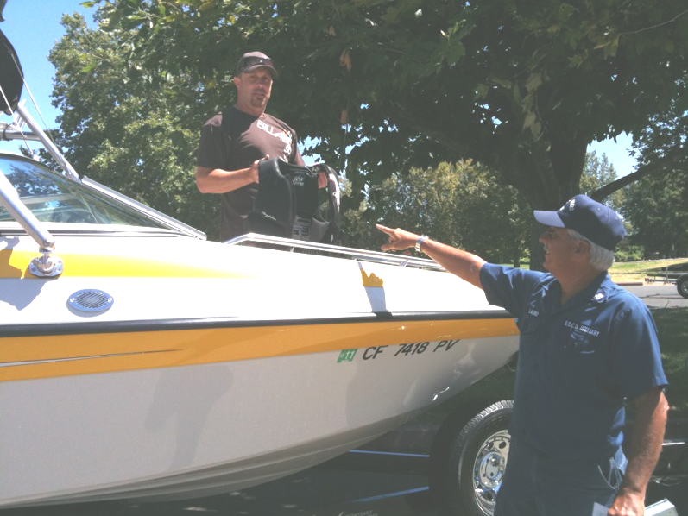
DSO-VE Mike Lauro explains how to tell if a
PFD is still useable during a Vessel Safety Check
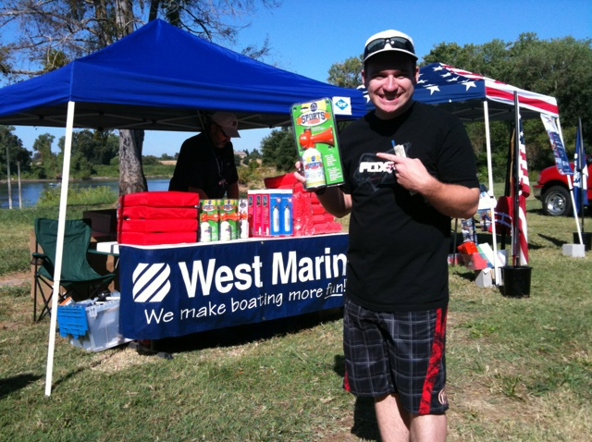
Vessel Owner buys a sound producing device, required to pass his Vessel Safety Check
A big thank you to West Marine to being available for this event!

FSO-PV Carrie Van De Boom had many different information packets
available at the red, white and blue booth next to West Marine.

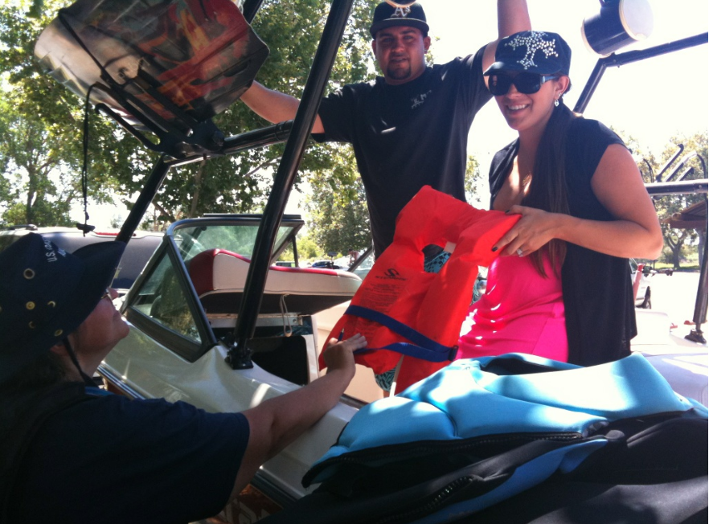
Vessel Examiner Jan Jewell examines PFDs during a VSC

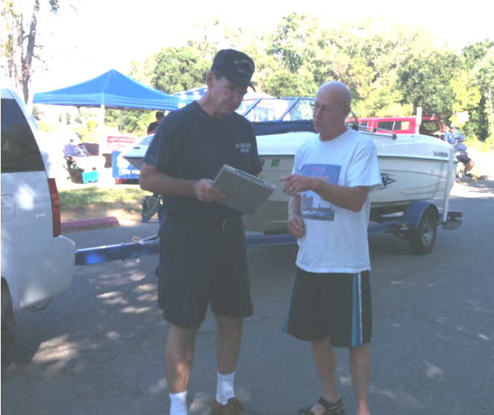
Vessel Examiner Jim Ippolito describes the list of items
needed to pass a Vessel Safety Check

